**W09**

**Chapter 9: The Window Object**

<https://www.sitepoint.com/premium/books/javascript-novice-to-ninja-2nd-edition/read/9>

#### The Path and Domain of Cookies

By default, cookies can only be read by pages inside the same directory and domain as the file was set. This is for security reasons so that access to the cookie is limited.

The path can be changed so that any page in the root directory can read the cookie. It’s done by adding the string ; path=/ to the end of the cookie when it is set:

Copy

document.cookie = 'name=Batman; path=/'

It’s also possible to set the domain by adding "; domain=domainName" to the end of the cookie:

Copy

document.cookie = 'name=Batman; domain=sitepoint.com';

A cookie can only be read by the domain that created it anyway, but doing this will allow all subdomains of sitepoint.com (such as javascript.sitepoint.com and books.sitepoint.com) to read it.

#### Secure Cookies

Adding the string ; secure to the end of a cookie will ensure it’s only transmitted over a secure HTTPS network:

Copy

document.cookie = 'name=Batman; secure';

### Deleting Cookies

To remove a cookie, you need to set it to expire at a time in the past:

Copy

document.cookie = 'name=Batman; expires=Thu, 01 Jan 1970 00:00:01 GMT';

If a cookie is a session cookie, it will expire when the tab or window is closed.

#### Cumbersome Cookies

JavaScript’s cookie handling is quite basic and can also be quite cumbersome. Many developers use a library such as [Cookies.js](https://github.com/ScottHamper/Cookies) or [jsCookie](https://github.com/js-cookie/js-cookie). You could even have a go at developing your own set of functions to make dealing with cookies easier.

## **setInterval()**

The window.setInterval() method works in a similar way to window.setTimeout(), except that it will repeatedly invoke the callback function after every given number of milliseconds.

The previous example used an anonymous function, but it is also possible to use a named function like so:

Copy

*function* chant(){ console.log('Beetlejuice'); }

Now we can set up the interval and assign it to a variable:

Copy

*const* summon = window.setInterval(chant,1000);<< 6

This should show the message “Beetlejuice” in the console every second (1,000 milliseconds).

To stop this, we can use the window.clearInterval() method and the variable repeat as an argument (this is because the window.setInterval() method returns its ID, so this will be assigned to the variable repeat):

Copy

window.clearInterval(summon);

requestAnimationFrame

This method of the window object works in much the same way as the window.setInterval() method, although it has a number of improvements to optimize its performance. These include making the most of the browser’s built-in graphics-handling capabilities, and not running the animation when the tab is inactive, resulting in a much smoother performance. It’s supported in all major browsers, including Internet Explorer from version 10 onwards. Change the code in main.js to the following:

Copy

*const* squareElement = document.getElementById('square');*let* angle = 0;

*function* rotate() { angle = (angle + 2)%360; squareElement.style.transform = `rotate(${angle}deg)` window.requestAnimationFrame(rotate);}

*const* id = requestAnimationFrame(rotate);

This is similar to the earlier code, but this time we place the rotation code inside a function called rotate. The last line of this function uses the window.requestAnimationFrame() method and takes the rotate() function as an argument. This will then call the rotate() function recursively. The frame rate cannot be set using requestAnimationFrame(); it’s usually 60 frames per second, although it’s optimized for the device being used.

To start the animation, we need to call the requestAnimationFrame() method, giving the rotate() function as an argument. This will return a unique ID that can be employed to stop the animation using the window.cancelAnimationFrame() method:

Copy

cancelAnimationFrame(id);

Refresh the animation.html page and you should notice that the animation is much faster and smoother than before, as shown below.

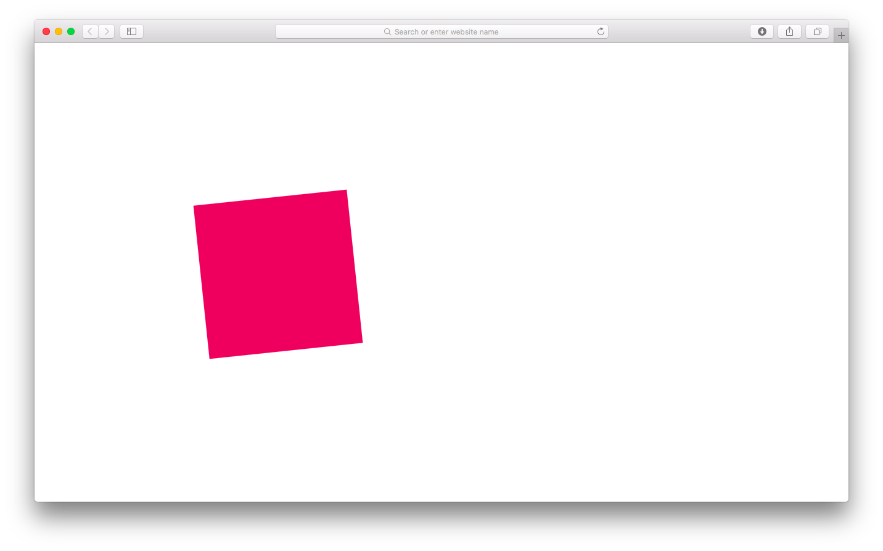

Animation in the browser

Consider Using CSS Instead

The rotation animation example demonstrates how JavaScript can be used to perform animations in the browser. It could also be achieved using pure CSS animation with the following style rules in styles.css:

Copy

#square { margin: 100px; width: 100px; height: 100px; background: #cc0; animation: spin 4s linear infinite;}

@keyframes spin { *from* { transform:rotate(0deg); } to { transform:rotate(3600deg); } }

In general, it is typically better to use CSS for any animation effects, although there may be times when JavaScript might be the better solution.

**Chapter 14: HTML APIs**

<https://www.sitepoint.com/premium/books/javascript-novice-to-ninja-2nd-edition/read/9/k01nwut8>

*HTML APIs*

* Local storage
* Geolocation
* Web workers
* Multimedia
* Canvas

## **The data- Attribute**

The data- attribute is a way of embedding data in a web page using custom attributes that are ignored by the browser. They’re also private to a page, so are not intended to be used by an external service – their sole purpose is to be used by a JavaScript program. This means they’re perfect for adding data that can be used as a hook that the program utilizes to access information about a particular element on the page.

The names of these attributes can be decided by the developer, but they must use the following format:

* Start with data-.
* Contain only lowercase letters, numbers, hyphens, dots, colons or underscores.
* Include an optional string value.

Examples could be:

Copy

data-powers = 'flight superSpeed'data-rating = '5' data-dropdown data-user = 'DAZ' data-max-length = '32'

The information contained in the attributes can be used to identify particular elements. For example, all the elements with an attribute of data-dropdown could be identified as dropdown menu. The values of the attributes can also be used to filter different elements. For example, we could find all the elements that have a data-rating value of 3 or more.

Each element has a dataset property that can be used to access any data- attributes it contains. Here’s an example of some markup:

Copy

<div id='hero' data-powers='flight superSpeed'> Superman</div>

The data-powers attribute can be accessed using the following code:

Copy

*const* superman = document.getElementById('hero');*const* powers = superman.dataset.powers;<< 'flight superSpeed'

Notice that the data- prefix is dropped. To access the attribute, powers is used as if it’s a property of the dataset object. If a data- attribute’s name contains hyphens, they are replaced with camel-case notation, so data-max-length would be accessed using dataset.maxLength.

### Geolocation

The Geolocation API is used to obtain the geographical position of the device. This means it can be used to find the user’s exact location, then link to nearby places or measure the speed at which the user is moving. This information can then be used to filter data based on the user's location or speed and direction of travel. An example of this might be a search function that returns results based on your location. Because of privacy concerns, permission to use this has to be granted by the user first.

If geolocation is available, it will be a property of the navigator object that we met in Chapter 9. This property has a method called getCurrentPosition() that will return a position object to a specified callback function, called youAreHere() in the example:

Copy

navigator.geolocation.getCurrentPosition(youAreHere);

The position object passed to the youAreHere() function has a coords property with a latitude and longitude property, which together give the coordinates of the device. These coordinates can then be used in conjunction with other applications or web services (such as a mapping service) to obtain the user’s exact location. In this example, we simply show an alert dialog that displays the user’s coordinates:

Copy

*function* youAreHere(position) { console.log(`Latitude: ${position.coords.latitude}, Longitude: ${position.coords.longitude}`); }

The position object has several other properties that can be used to find out information about the location and movement of the device:

* position.speed property returns the ground speed of the device in meters per second.
* position.altitude property returns an estimate of the device’s altitude in meters above the [WGS84](http://en.wikipedia.org/wiki/World_Geodetic_System) ellipsoid, which is a standard measurement for the center of the Earth.
* position.heading property returns the direction the device is moving in. This is measured as a bearing in degrees, clockwise from North.
* position.timestamp property returns the time that the position information was recorded.

The position object also has properties that calculate the accuracy of the measurements. These can be useful, as sometimes you only need to know the town or city users are in, while at other times you may need their exact position. position.accuracy property returns the accuracy of the latitude and longitude properties in meters. The lower the returned value, the more accurate the measurements are, as is the case for the position.altitudeAccuracy property, which returns the accuracy of the altitude property in meters.

In addition, the geolocation object has a watchPosition() method that will call a callback function every time the position of the device is updated. This method returns an ID that can be used to reference the position being watched:

Copy

*const* id = navigator.geolocation.watchPosition(youAreHere);

The clearWatch() method can be used to stop the callback being called, using the ID of the watch as an argument:

Copy

navigator.geolocation.clearWatch(id);

The Geolocation API provides a useful interface for adding location-based information to a website or application. More information can be found at the [Mozilla Developer Network](https://developer.mozilla.org/en-US/docs/Web/API/Geolocation/Using_geolocation).

### Web Workers

We saw in earlier chapters that JavaScript is a single-threaded language, meaning that only one process can run at one time. Web workers allow processes to be run in the background, adding support for concurrency in JavaScript. The idea is that any processes that could take a long time are carried out in the background, so a website will continue to function without fear of the dreaded 'script has become unresponsive' message that occurs when a script runs for too long, shown below.

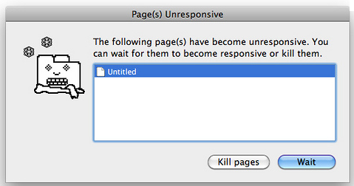

An unresponsive script

To get started, use the Worker() constructor function to create a new worker:

Copy

*const* worker = *new* Worker('task.js');

#### Chrome Support

At the time of writing, the Chrome browser won't let you run workers from local files like this. A workaround is start Chrome using the --allow-file-access-from-files flag, or simply use a different browser for this example.

If you decide to use the --allow-file-access-from-files flag, make sure you only use this for development, rather than for regular browsing.

This function takes the name of another JavaScript file as an argument. In the example, this is a file called 'task.js'. If this file exists, it will be downloaded asynchronously. The worker will only start once the file has finished downloading completely. If the file doesn’t exist, an error is thrown.

The variable that’s assigned to the constructor function (worker in our example) can now be used to refer to the worker in the main program. In the worker script ('task.js'), the keyword self is used to refer to the worker.

Web workers use the concept of messages to communicate back and forth between the main script and worker script. The postMessage() method can be used to send a message and start the worker working. The argument to this method can send any data to the web worker. To post a message to the worker, the following code is used inside the main script:

Copy

worker.postMessage('Hello');

To post a message from the worker, the following is used in the worker script:

Copy

self.postMessage('Finished');

When a message is posted, a message event is fired, so they can be dealt with using an event listener. The data sent with the message as an argument is stored in the data property of the event object that’s passed to the callback function. The following example would log any data returned from the worker to the console:

Copy

worker.addEventListener('message', (event) => { console.log(event.data);}, false);

When a worker has completed its task, it can be stopped using the terminate() method from within the main script:

Copy

worker.terminate();

Or using the close() method from inside the worker script:

Copy

self.close();

#### A Factorizing Example

Back in Chapter 10, we created a function that found the factors of a given number. This works well, but can take a long time to find the factors of large numbers. If it was used in a website, it would stop any other code from running while it calculated the factors. To demonstrate this, save the following code in a file called 'factors.html':

Copy

<!doctype html><html lang='en'><head> <meta charset='utf-8'> <title>Factorizor</title> </head><body> <button id='rainbow'>Change Color</button> <form> <label *for*='number'>Enter a Number to Factorize:</label> <input id='number' type='number' name='number' min=1 value='20'> <button type='submit'>Submit</button> </form> <div id='output'></div> <script src='main.js'></script></body></html>

This web page has a button that will change the background color of the page, and an input field where a number can be entered. The factors will be displayed inside the output div. To get this working, create a file called main.js in the same directory as 'factors.html' that contains the following code:

Copy

*const* btn = document.getElementById('rainbow');

*const* rainbow = ['red','orange','yellow','green','blue','rebeccapurple','violet'];

*function* change() { document.body.style.background = rainbow[Math.floor(7* Math.random())];}btn.addEventListener('click', change);

This first piece of code was covered way back in Chapter 1 and uses an event listener to change the background color if the button is clicked. We also need to factorize the number entered in the form, so add this code to the end of main.js:

Copy

*const* form = document.forms[0];form.addEventListener('submit', factorize, false);

*function* factorize(event) { *// prevent the form from being submitted* event.preventDefault();

*const* number = Number(form.number.value); document.getElementById('output').innerText = factorsOf(number); }

*function* factorsOf(n) { *if*(Number.isNaN(Number(n))) { *throw* *new* RangeError('Argument Error: Value must be an integer'); } *if*(n < 0) { *throw* *new* RangeError('Argument Error: Number must be positive'); } *if*(!Number.isInteger(n)) { *throw* *new* RangeError('Argument Error: Number must be an integer'); } *const* factors = []; *for* (*let* i=1 , max = Math.sqrt(n); i <= max ; i++) { *if* (n%i === 0){ factors.push(i,n/i); } } *return* factors.sort((a,b) => a - b);}

This uses the same factorsof() function from Chapter 10 and adds a submit event listener to the form. When the form is submitted, it will find the factors of the number in the input field, then place the result inside the output div.

This works well, even coping with some large numbers, as can be seen in the screenshot below.

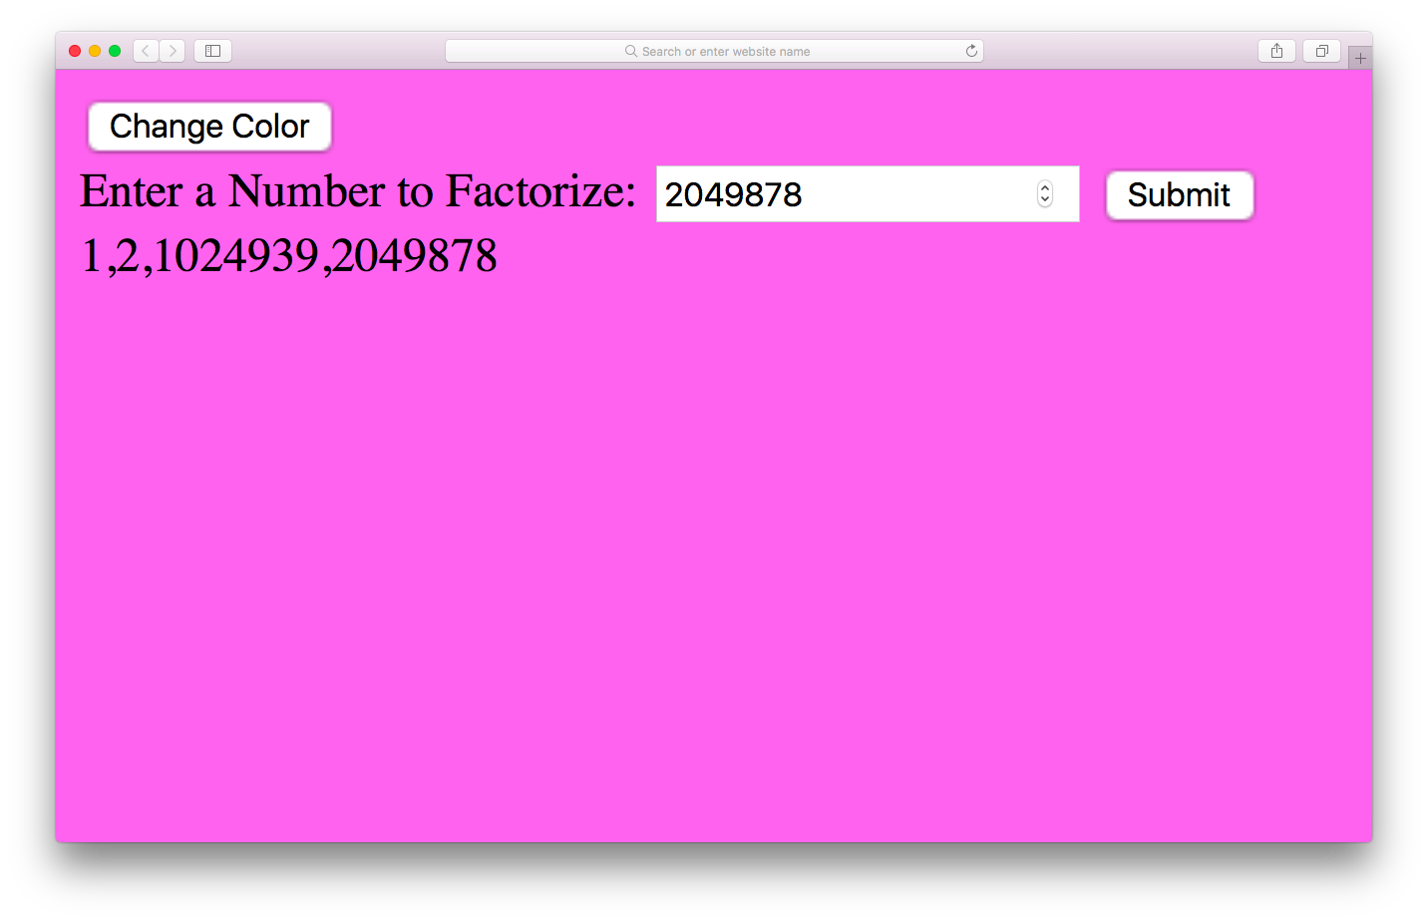

Our Factorizor in action

But if you enter a sizable number (around 18–20 digits), it takes longer to process the answer, and the browser will display a warning or the dreaded 'rainbow-whirl' that means something is taking a long time.

To make matters worse, it’s impossible to click on the 'Change Color' button while the factors are being calculated ― the whole program freezes until the operation is complete. (If you recklessly decided to try a huge number and now have an unresponsive web page on your hands, you can simply close the tab and reopen it, or use the Chrome Task Manager to kill the process.)

The good news is that we can use web workers to solve this problem.

#### Running This Example

The file containing the worker code is expected to be hosted on a server. This is the best option, but if you want to run an example locally you need to turn off the [*same origin policy*](https://developer.mozilla.org/en-US/docs/Same-origin_policy_for_file:_URIs) setting in the browser.

Firstly, we create a new file called factors.js; and save it in the same folder as main.js. Then we remove the factorsOf() function from the main.js file and add it into our new factors.js; file. We’ll be adding more to this file later, but first we need to edit the factorize() function in the main.js file so it looks like the following:

Copy

*function* factorize(event) { *// prevent the form from being submitted* event.preventDefault(); document.getElementById('output').innerHTML = '<p>This could take a while ...</p>'; *const* number = Number(form.number.value);

*if*(window.Worker) { *const* worker = *new* Worker('factors.js'); worker.postMessage(number); worker.addEventListener('message', (event) => { document.getElementById('output').innerHTML = event.data; }, false); }}

We start by preventing the form from being submitted, then display a message that says 'This could take a while ...'. This message is displayed until the worker returns a result, so in the cases of small numbers, this will hardly be seen.

After checking whether web workers are supported, it adds a new web worker. It then uses the postMessage() method to send a message to the worker, which is the number we want to factorize. When the number has been factorized, the worker will send a message back to say it has finished.

To deal with this, we set up an event listener that will fire when a message is received back from the worker. The information sent from the worker is stored in the data property of the event object, so we use innerHTML to insert the data into the output div.

Now we go back to the factors.js; file and add this event listener code to the end of the file:

Copy

self.addEventListener('message', (event) => {

*const* factors = String(factorsOf(Number(event.data))); self.postMessage(factors); self.close();

}, false);

This will fire when the worker receives a message, occurring when the form is submitted. The number to be factorized is stored in the event.data property. We use the factorsOf() function to find the factors of the number, then convert it into a string and send a message back containing the answer. We then use the close() method to terminate the worker, since its work is done.

Now if we test the code, it will still take a long time to factorize a long number, but the page will not freeze. You can also continue to change the background color while the factors are being calculated in the background.

#### Shared Web Workers

The examples we have seen so far are known as dedicated web workers. These are linked to the script that loaded the worker, and are unable to be used by another script. You can also create shared web workers that allow lots of different scripts on the same domain to access the same worker object. [You can read more about shared web workers in this post on SitePoint.](http://www.sitepoint.com/javascript-shared-web-workers-html5/)

Web workers allow computationally complex operations to be performed in a separate thread, meaning that the flow of a program won’t suffer interruptions, and an application will not freeze or hang. They are a useful feature that help to keep sites responsive, even when complicated operations are being carried out. You can find [more information about them at the Mozilla Developer Network.](https://developer.mozilla.org/en-US/docs/Web/Guide/Performance/Using_web_workers)

#### Service Workers

The Service Worker API allows a worker script to run in the background with the added benefit of being able to intercept network requests. This allows you to take alternative action if the network is offline, and effectively create app-like offline experiences. Service workers also allow access to push notifications and background syncing. Service workers require a secure network to run on HTTPS to avoid any malicious code hijacking network requests.

There are a large number of different examples of using the Service Worker API in [The Service Worker Cookbook](https://serviceworke.rs/), which is maintained by Mozilla.

### Websockets

As we saw in the last chapter, the main form of communication on the web has always been the HTTP protocol. This uses a system of request and response to send data back and forth. A problem with this method of communication is when you only get a response when a request is sent. But what if the response comes later? For example, imagine a chat application. You send a message to somebody then wait for a reply, but you can't get a reply unless you send them another request... and you'll only get the reply if they have sent the response when you send your request. How long do you wait until you send the next request? This was partially solved using Ajax and a method called ‘polling’ where a request was periodically sent to see if there had been a response.

Websocket is a new protocol that allows two-way communication with a server – also known as push messaging. This means that a connection is kept open and responses are ‘pushed’ to the client as soon as they are received.

To see this in action, we’ll create a mini-messaging application that uses the websocket protocol to communicate with an Echo server. This sends a response that is exactly the same as the message it receives.

Create a file called websocket.html and add the following HTML code:

Copy

*<!doctype html>*<html lang='en'><head> <meta charset='utf-8'> <title>Websocket Example</title></head><body> <form> <label for='message'>Enter a Message:</label> <input type='text' name='message'> <button type='submit'>Submit</button> </form> <div id='output'></div> <script src='main.js'></script></body></html>

Apart from the usual standard HTML elements, this has a form for entering and submitting a short message and an empty output <div> element, where the message and responses will be displayed.

Next we need to place our JavaScript code inside a file called main.js:

Copy

*const* URL = 'wss://echo.websocket.org/';*const* outputDiv = document.getElementById('output');*const* form = document.forms[0];*const* connection = *new* WebSocket(URL);

This sets up some variables to store information. The first is URL, which is the URL we’ll be using to connect to the websocket. Notice that it starts 'wss://' instead of 'https://' This is the secure protocol used by websockets instead of HTTP. The site is the Echo server hosted at [websocket.org](http://websocket.org/). This accepts messages then returns the same message (like an echo).

The next variable is outputDiv and it's used to store a reference to the <div> element where we will be displaying the messages. The form variable is also used to store a reference to the form element.

Last of all, we create a variable called connection that stores a reference to our websocket object. This is created using a constructor function, and takes the URL as a parameter. We will use the variable connection to refer to the websocket connection throughout the program.

When the code new WebSocket(URL) runs, it creates an instance of a WebSocket object and tries to connect to the URL. When this is successful, it fires an event called 'open'. This is one of a number of events that a WebSocket object can emit. To deal with it, we can add an event handler to main.js:

Copy

connection.addEventListener('open', () => { output('CONNECTED');}, false);

This works in the same way as the event handlers we’ve seen previously, and is called on the connection object. In this case, we call a function called output() with the string 'CONNECTED' provided as an argument. The output() is used to output messages to the screen. We need to add that function next:

Copy

*function* output(message) { *const* para = document.createElement('p'); para.innerHTML = message; outputDiv.appendChild(para);}

This function takes a string as an argument then appends a new paragraph element to the <div> with an ID of 'output'. The message is then placed inside this paragraph. This has the effect of producing a constant stream of messages inside this <div>.

Now we need to add some code to allow us to add some messages. We'll start by adding an event listener to deal with when the form is submitted:

Copy

form.addEventListener('submit', message, false);

This invokes a function called message(), so let's write that now:

Copy

*function* message(event) { event.preventDefault(); *const* text = form.message.value; output(`SENT: ${text}`); connection.send(text);}

First of all we stop the default behavior, so the form doesn't actually get submitted. Then we grab the value of the text input and store it in a local variable called text. We then use the output() function again to add the message to the 'output'<div>, with the phrase 'SENT:' at the start.

The last line is an important one. This calls a method of the connection object called send(). This sends the message to the URL that the websocket is connected to. When this message is received, the server will process it and send a response. The connection object waits for the response, and when it receives one, a 'message' event is fired. The 'echo.websocket.org' server simply responds with the same message, but any message could be processed in a variety of ways before sending a response.

Let's create an event handler to deal with the response:

Copy

connection.addEventListener('message', (event) => { output(`RESPONSE: ${event.data}`);}, false);

This uses the event object that is provided as an argument to the event, and we can use the data property to access the data that was returned. It's then a simple case of using the output() function again to add this message to the growing stream of messages in the 'output'<div>, but this time with the phrase 'RESPONSE:' added to the beginning.

If you open websocket.html in a browser, you should see something similar to in the screenshot below:

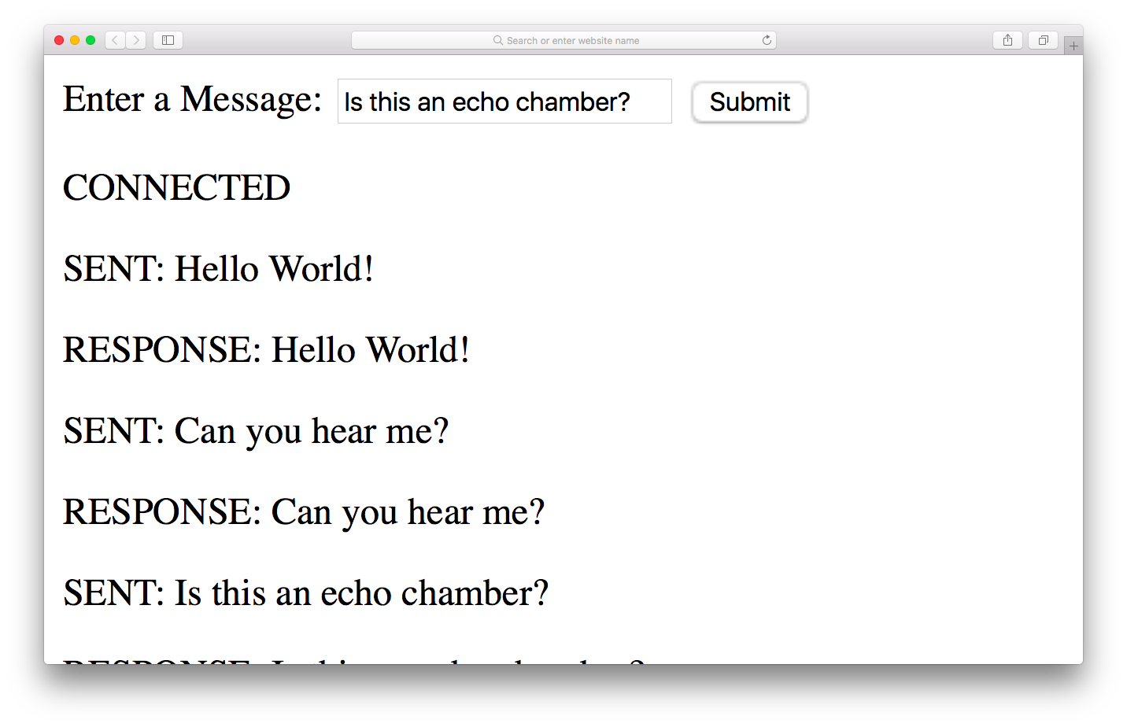

Websocket messages

There are a couple of other events that the connection object responds to that are worth knowing about: The close event occurs when the connection is closed, which can be done using the close() method. The error event is fired when any sort of error occurs with the connection. The information about the error can be accessed in the data property of the event object.

Typical event listeners for these events might looks like the ones below:

Copy

connection.addEventListener('close', () => { output('DISCONNECTED');}, false);

connection.addEventListener('error', (event) => {output(`<span style='color: red;'>ERROR: ${event.data}</span>`);}, false);

Websockets are an exciting technology, and you can see lots of examples of how they can be used, as well as finding out more about them at [websocket.org](https://www.websocket.org/demos.html) and in [this article on SitePoint](https://www.sitepoint.com/real-time-apps-websockets-server-sent-events/).

### Websockets

BookmarkShare

As we saw in the last chapter, the main form of communication on the web has always been the HTTP protocol. This uses a system of request and response to send data back and forth. A problem with this method of communication is when you only get a response when a request is sent. But what if the response comes later? For example, imagine a chat application. You send a message to somebody then wait for a reply, but you can't get a reply unless you send them another request... and you'll only get the reply if they have sent the response when you send your request. How long do you wait until you send the next request? This was partially solved using Ajax and a method called ‘polling’ where a request was periodically sent to see if there had been a response.

Websocket is a new protocol that allows two-way communication with a server – also known as push messaging. This means that a connection is kept open and responses are ‘pushed’ to the client as soon as they are received.

To see this in action, we’ll create a mini-messaging application that uses the websocket protocol to communicate with an Echo server. This sends a response that is exactly the same as the message it receives.

Create a file called websocket.html and add the following HTML code:

Copy

*<!doctype html>*<html lang='en'><head> <meta charset='utf-8'> <title>Websocket Example</title></head><body> <form> <label for='message'>Enter a Message:</label> <input type='text' name='message'> <button type='submit'>Submit</button> </form> <div id='output'></div> <script src='main.js'></script></body></html>

Apart from the usual standard HTML elements, this has a form for entering and submitting a short message and an empty output <div> element, where the message and responses will be displayed.

Next we need to place our JavaScript code inside a file called main.js:

Copy

*const* URL = 'wss://echo.websocket.org/';*const* outputDiv = document.getElementById('output');*const* form = document.forms[0];*const* connection = *new* WebSocket(URL);

This sets up some variables to store information. The first is URL, which is the URL we’ll be using to connect to the websocket. Notice that it starts 'wss://' instead of 'https://' This is the secure protocol used by websockets instead of HTTP. The site is the Echo server hosted at [websocket.org](http://websocket.org/). This accepts messages then returns the same message (like an echo).

The next variable is outputDiv and it's used to store a reference to the <div> element where we will be displaying the messages. The form variable is also used to store a reference to the form element.

Last of all, we create a variable called connection that stores a reference to our websocket object. This is created using a constructor function, and takes the URL as a parameter. We will use the variable connection to refer to the websocket connection throughout the program.

When the code new WebSocket(URL) runs, it creates an instance of a WebSocket object and tries to connect to the URL. When this is successful, it fires an event called 'open'. This is one of a number of events that a WebSocket object can emit. To deal with it, we can add an event handler to main.js:

Copy

connection.addEventListener('open', () => { output('CONNECTED');}, false);

This works in the same way as the event handlers we’ve seen previously, and is called on the connection object. In this case, we call a function called output() with the string 'CONNECTED' provided as an argument. The output() is used to output messages to the screen. We need to add that function next:

Copy

*function* output(message) { *const* para = document.createElement('p'); para.innerHTML = message; outputDiv.appendChild(para);}

This function takes a string as an argument then appends a new paragraph element to the <div> with an ID of 'output'. The message is then placed inside this paragraph. This has the effect of producing a constant stream of messages inside this <div>.

Now we need to add some code to allow us to add some messages. We'll start by adding an event listener to deal with when the form is submitted:

Copy

form.addEventListener('submit', message, false);

This invokes a function called message(), so let's write that now:

Copy

*function* message(event) { event.preventDefault(); *const* text = form.message.value; output(`SENT: ${text}`); connection.send(text);}

First of all we stop the default behavior, so the form doesn't actually get submitted. Then we grab the value of the text input and store it in a local variable called text. We then use the output() function again to add the message to the 'output'<div>, with the phrase 'SENT:' at the start.

The last line is an important one. This calls a method of the connection object called send(). This sends the message to the URL that the websocket is connected to. When this message is received, the server will process it and send a response. The connection object waits for the response, and when it receives one, a 'message' event is fired. The 'echo.websocket.org' server simply responds with the same message, but any message could be processed in a variety of ways before sending a response.

Let's create an event handler to deal with the response:

Copy

connection.addEventListener('message', (event) => { output(`RESPONSE: ${event.data}`);}, false);

This uses the event object that is provided as an argument to the event, and we can use the data property to access the data that was returned. It's then a simple case of using the output() function again to add this message to the growing stream of messages in the 'output'<div>, but this time with the phrase 'RESPONSE:' added to the beginning.

If you open websocket.html in a browser, you should see something similar to in the screenshot below:



Websocket messages

There are a couple of other events that the connection object responds to that are worth knowing about: The close event occurs when the connection is closed, which can be done using the close() method. The error event is fired when any sort of error occurs with the connection. The information about the error can be accessed in the data property of the event object.

Typical event listeners for these events might looks like the ones below:

Copy

connection.addEventListener('close', () => { output('DISCONNECTED');}, false);

connection.addEventListener('error', (event) => {output(`<span style='color: red;'>ERROR: ${event.data}</span>`);}, false);

Websockets are an exciting technology, and you can see lots of examples of how they can be used, as well as finding out more about them at [websocket.org](https://www.websocket.org/demos.html) and in [this article on SitePoint](https://www.sitepoint.com/real-time-apps-websockets-server-sent-events/).

### Notifications

The Notification API allows you to show messages using the system's notifications. This is usually a popup in the corner of the screen, but it changes depending on the operating system. An advantage of using the system notification is that they will still be displayed even if the web page that calls them isn't the current tab.

Before you can send notifications, you need to get permission granted by the user. This can be achieved using the requestPermission() method of a Notification global object. To try this out, visit any website in your browser (https://sitepoint.com for example), and enter the following code in the console:

Copy

*if*(window.Notification) { Notification.requestPermission();}

This will ask for permission, similar to in the screenshot below:

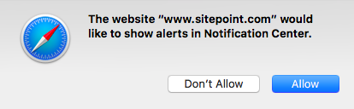

Permission for notifications

This returns a promise with the permission property of the Notification object set to either 'granted' or 'denied'. If it’s set to granted, you can create a new notification using a constructor function, like so:

Copy

*if*(window.Notification) { Notification.requestPermission() .then((permission) => { *if*(Notification.permission === 'granted') { *new* Notification('Hello JavaScript!'); } });}

This will produce a system notification with the title 'Hello JavaScript!'.

The constructor function's first parameter is the title of the notification, and is required. The function also accepts a second parameter, which is an object of options. These include body that specifies any text that you want to appear below the title, and icon where you can specify a link to an image that will be displayed as part of the notification:

Copy

*const* notification = *new* Notification('JavaScript: Novice to Ninja',{ body: 'The new book from SitePoint', icon: 'sitepointlogo.png'});

Depending on your browser and operating system, some notifications close automatically after a short period of time, and some will stay on the screen until the user clicks on them. You can close the notification programmatically using the close() method:

Copy

notification.close();

The notification instance has a number of events that it can react to, including click (when a user clicks on it), show (when the notification appears) and close (when the notification is closed).

For example, you could open a new window when the user clicked on the notification using the following code:

Copy

notification.addEventListener('click', () => {window.open('https://sitepoint.com')}, false);

You can read more about the [Notification API on MDN](https://developer.mozilla.org/en/docs/Web/API/notification) and [this article on SitePoint](https://www.sitepoint.com/browser-notification-api/).

### Notifications

The Notification API allows you to show messages using the system's notifications. This is usually a popup in the corner of the screen, but it changes depending on the operating system. An advantage of using the system notification is that they will still be displayed even if the web page that calls them isn't the current tab.

Before you can send notifications, you need to get permission granted by the user. This can be achieved using the requestPermission() method of a Notification global object. To try this out, visit any website in your browser (https://sitepoint.com for example), and enter the following code in the console:

Copy

*if*(window.Notification) { Notification.requestPermission();}

This will ask for permission, similar to in the screenshot below:



Permission for notifications

This returns a promise with the permission property of the Notification object set to either 'granted' or 'denied'. If it’s set to granted, you can create a new notification using a constructor function, like so:

Copy

*if*(window.Notification) { Notification.requestPermission() .then((permission) => { *if*(Notification.permission === 'granted') { *new* Notification('Hello JavaScript!'); } });}

This will produce a system notification with the title 'Hello JavaScript!'.

The constructor function's first parameter is the title of the notification, and is required. The function also accepts a second parameter, which is an object of options. These include body that specifies any text that you want to appear below the title, and icon where you can specify a link to an image that will be displayed as part of the notification:

Copy

*const* notification = *new* Notification('JavaScript: Novice to Ninja',{ body: 'The new book from SitePoint', icon: 'sitepointlogo.png'});

Depending on your browser and operating system, some notifications close automatically after a short period of time, and some will stay on the screen until the user clicks on them. You can close the notification programmatically using the close() method:

Copy

notification.close();

The notification instance has a number of events that it can react to, including click (when a user clicks on it), show (when the notification appears) and close (when the notification is closed).

For example, you could open a new window when the user clicked on the notification using the following code:

Copy

notification.addEventListener('click', () => {window.open('https://sitepoint.com')}, false);

You can read more about the [Notification API on MDN](https://developer.mozilla.org/en/docs/Web/API/notification) and [this article on SitePoint](https://www.sitepoint.com/browser-notification-api/).

## **Shims and Polyfills**

HTML5 APIs progress at a rapid rate ― new APIs are constantly being introduced, and existing APIs often change. Modern browsers are very quick to update and implement many of the changes, but you can’t always guarantee that users will have the most up-to-date browser. This is where a shim or a polyfill comes in handy. These are libraries of code that allow you to use the APIs as usual. They then fill in the necessary code that's not provided natively by the user’s browser.

The terms shim and polyfill are often used interchangeably. The main difference between them is that a shim is a piece of code that adds some missing functionality to a browser, although the implementation method may differ slightly from the standard API. A polyfill is a shim that achieves the same functionality, while also using the API commands that would be used if the feature was supported natively.

This means that your code can use the APIs as normal and it should work as expected in older browsers. The advantage here is that the same set of standard API commands can be used ― you don’t need to write additional code to deal with different levels of support. And when users update their browsers, the transition will be seamless, as their experience will remain the same. Once you are confident that enough users have up-to-date browsers, you can remove the polyfill code without having to update any actual JavaScript code.

A comprehensive [list of shims and polyfills is maintained by the Modernizr team](https://github.com/Modernizr/Modernizr/wiki/HTML5-Cross-Browser-Polyfills).

# Managing the modern Front-end workflow

Development workflow has become quite complicated for Web development. Lets take a medium sized project for example. It could have dozens of javascript files, several css files, 3rd party libraries, and who knows how many icons, fonts, images, etc are involved. It might be using a CSS preprocessor like SASS or it could be transpiling the Javascript to make sure that new features will work in older browsers.

A potential list of tasks that could need to happen everytime something changes is this:

1. Lint CSS and Javascript to find any coding issues.
2. Run unit tests to make sure nothing got broken with your last changes
3. compile all SCSS/LESS to CSS
4. concatinate all CSS into one file for faster loading,
5. Minify the CSS to reduce file size.
6. Transpile Javascript with Babel for wider support for older browsers
7. Concatinate all JS files into one file for faster loading
8. Minify and Uglify Javascript to reduce size
9. Do the same for any 3rd party CSS or JS
10. Move all the production assets into a distribution directory to separate them from the development stuff

Whew! That's a big list...and they have to happen A LOT!

It's no wonder that developers have produced tools to help manage all of this. This activity will introduce a simple implementation of some of these tools. The tools fall into three catagories:

1. Package managers: These keep track of all of the external dependencies for our app. Both development tools and libraries we might be using. It knows not only which packages to download...but tracks versions as well. We are using **npm** for our package manager.
2. Bundlers: bundlers handle the compiling, transpiling, concatinating, minifying, and moving around of assets in our project. We are using **Parcel** as our bundler. Another common bundler is Webpack
3. Task managers: these keep track of what needs to be done and when. There will generally be scripts defined in the task manager for each phase of development. Our project is fairly simple so we are just using **npm** again for task manager. Other common managers are Grunt or Gulp

## Prerequisites

* It will really help if you are familiar with the command line for your Operating system. Here is a quick overview to the [command line for Mac](http://byui-cit.github.io/advcss/resources/cmd-line-mac.html) and the [command line for Windows](http://byui-cit.github.io/advcss/resources/cmd-line-pc.html) if you need a primer.
* You must have [NodeJS](https://nodejs.org/en/) installed on your computer. Most of these tools require it. Goto [this software setup](https://byui-cit.github.io/advcss/lesson01/l01-software.html) walkthrough and skip to the Node part for instructions for your OS.
* The [boilerplate code](https://byui-cit.github.io/cit261/resources/parcel.zip). Download this and extract it somewhere you can find it on your computer. If you are not confident with the command line for your operating system then I recommend placing it on your Desktop or in Documents.

## Activity

1. After completing the setup above open the command line on your computer and navigate to the directory where you saved the boilerplate code.
2. There are a bunch of additional assets that need to be installed. Type **npm install** to get those. Once that is finished you will notice a new directory called node_modules.
3. Open the folder with the boilerplate code in your editor. You will notice a few things.
   * **node_modules** : This is where all of the 3rd party tools we will need got installed to when you ran 'npm install' above.
   * **src**: This is where I have placed all of the code. This is where you will work.
   * **package.json**: This file contains the information about the dependencies for the project. When you ran the install command this is how it knew what to go get. We can also define a few scripts in here.
   * Various other configuration files.
4. Open the **package.json** file in your editor. Look first at the **scripts** portion. You should see the following possible commands:
   * **prestart**: This gets run automatically when you run **start** or you can run it by itself as well. It does a bit of cleanup for us.
   * **start**: This command starts up our bundler Parcel. This starts a webserver on port 1234, clears out the 'build' directory, builds the new files based on what is in 'src' (transpiles with babel, compiles our Sass if we are using it, and concatenates all of our CSS and JS into separate files.), watches our files for changes, re-compiles everything on a change and refreshes the browser. It places the code in a **build** directory. Quite a lot for one simple command!
   * **prebuild**: just like prestart this runs automatically when we run the **build** process.
   * **build**: This command gets our code ready for distribution. It runs a similar process to the **start** above, but also minifies the CSS and JS. It creates a **dist** directory. If you were publishing your app to a server that is the code you would move.
   * **watch** is very similar to **start**
   * **lint** runs a linter on your Javascript and will make recommendations and sometimes even changes to your code based on the rules it is configured with.
5. You can run any of those scripts by navigating to the project directory and typing **npm run command**. So to start parcel running and launch it's built in web server you would type **npm run start**
6. Look next at the **devDependencies** section. This lists out all of the tools we are using to facilitate our development. These tools will not be a part of the distribution code. This is a good thing, I don't know if you noticed...but the **node_modules** directory is over 100MB!
7. To start up your tools go ahead and run **npm run start** in the command line. You should see the **build** directory get created and populated with files. And if you point your web browser to **http://localhost:1234** you will see a simple page. Make a change to any of the files in the project and the browser will auto-refresh.
8. When you are done working you can hit **ctrl-c** in your command line to end that process.